Booking Form

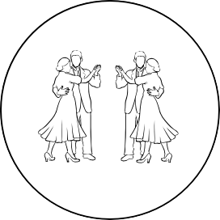

Termonfeckin Set Dancing Festival

An Grianán, Termonfeckin,

Co. Louth, A92 X9TF

Termonfeckinsetdancingfestiva.ie

N

I

C

N

e

A

c

D

k

T

i

E

n

S

D

N

T

E

e

K

E

r

E

m

W

G

# CUSTOMER INFORMATION:

# DATE:

NAME:

ADDRESS:

PHONE:

EMAIL:

# ROOM TYPE:

ROOM TYPE

TICK

ADDITIONAL NAMES

SINGLE

DOUBLE

TWIN TRIPLE

QUAD BUNGALOW

(UP TO 8 PEOPLE)

COST PER PERSON:

n

f

o

DEPOSIT: TOTAL:

CONTACT INFORMATION

PLEASE COMPLETE THE BOOKING FORM & SEND IT ALONG WITH YOUR

DEPOSIT (€50 PER PERSON) TO PÁDRAIG MC ENEANY, CUAINÍN, MARTINSTOWN, TOGHER, CO LOUTH.

ALTERNATIVELY, PLEASE SUBMIT THE FORM ONLINE & WE WILL CONTACT YOU TO TAKE YOUR DEPOSIT.